湖 北 大 学
曼城联合学院

2025—2026学年度
第2学期

学 生 实 验 报 告 册

课程名称： | 人工智能技术与应用
任课老师： | 王雷春
专业年级： | 24级软件工程
学号： | 202431123002076/202431123002054
学生姓名： | 寇天弈/秦天

学生实验守则

1、学生在规定的时间内进行实验，不得无故缺席或迟到。
2、学生在每次实验前对排定要做的实验应进行预习，并按要求作好预习报告。
3、每次实验前，必须交上次实验报告和本次实验预习报告，并经指导教师提问、检查同意后，才可进行本次实验。
4、学生进入实验室指定位置后，首先根据仪器清单核对自己使用的仪器是否有缺少或损坏，发现问题及时向指导教师报告，严禁擅自动用别组仪器。
5、实验时必须有实事求是、严肃认真的科学态度，严格遵守仪器操作规程和注意事项。
6、实验完毕应将实验数据交给指导教师检查，合格后，整理复原好仪器设备，方可离开实验室。
7、保持实验室肃静和整洁，不得大声喧哗，乱丢垃圾和吃东西。
8、学生在实验过程中，由于不遵守操作规程或未经许可，擅自进行实验而造成事故、损坏仪器设备，应及时报告，并填写损坏清单，按院有关规定进行赔偿。
验 报 告 单

实验名称： | 实验4 卷积神经网络及应用 实验
实验课时： | 2 | 报告日期： | 2026.4.23
成绩： |  | 批阅日期： | 2026.4.28
一、实验目的：
- 深入理解前馈神经网络（多层感知机）的基本结构和工作原理。
- 掌握神经网络从构建、训练到评估的完整流程。
- 通过对比实验，探究不同激活函数、优化算法和网络结构对模型性能的影响。
- 直观体会过拟合现象，并实践应用Dropout等正则化技术。
- 实验内容和实验结果：
- 题目
任务一：构建一个基础的多层感知机
- 数据预处理：
加载Fashion-MNIST数据集，划分训练集和验证集（例如，从训练集划分10%作为验证集）。
将图像数据从28x28矩阵展平为784维向量。
将像素值归一化到[0, 1]区间。
将标签转换为独热编码（如果使用交叉熵损失，框架通常自动处理）。
- 网络架构设计：
构建一个包含一个隐藏层的MLP：输入层(784) → 隐藏层(256个神经元) → 输出层(10)。
隐藏层使用ReLU激活函数，输出层使用Softmax（分类任务）。
使用交叉熵损失和Adam优化器（学习率=0.001）。
- 训练与评估：
设置批量大小为64，训练轮数为20。
在每轮训练后，记录训练集和验证集上的损失和准确率。

源代码
寇天弈
import argparse
import random
from datetime import datetime
from pathlib import Path
from typing import Dict, List, Tuple
import matplotlib.pyplot as plt
import numpy as np
import torch
from sklearn.metrics import classification_report, confusion_matrix
from torch import nn
from torch.utils.data import DataLoader
from torchvision import datasets, transforms
CLASS_NAMES = [
"T-shirt/top",
"Trouser",
"Pullover",
"Dress",
"Coat",
"Sandal",
"Shirt",
"Sneaker",
"Bag",
"Ankle boot",
]
def set_seed(seed: int) -> None:
random.seed(seed)
np.random.seed(seed)
torch.manual_seed(seed)
torch.cuda.manual_seed_all(seed)
class FashionCNN(nn.Module):
"""Strictly follows the provided grid structure image."""
def __init__(self, conv1_out: int = 32, conv2_out: int = 64) -> None:
super().__init__()
self.features = nn.Sequential(
nn.Conv2d(1, conv1_out, kernel_size=3, padding=1),
nn.ReLU(inplace=True),
nn.MaxPool2d(kernel_size=2, stride=2),
nn.Conv2d(conv1_out, conv2_out, kernel_size=3, padding=1),
nn.ReLU(inplace=True),
nn.MaxPool2d(kernel_size=2, stride=2),
)
self.classifier = nn.Sequential(
nn.Flatten(),
nn.Linear(conv2_out * 7 * 7, 128),
nn.ReLU(inplace=True),
nn.Linear(128, 10),
)
def forward(self, x: torch.Tensor) -> torch.Tensor:
x = self.features(x)
x = self.classifier(x)
return x
def train_one_epoch(
model: nn.Module,
loader: DataLoader,
criterion: nn.Module,
optimizer: torch.optim.Optimizer,
device: torch.device,
) -> float:
model.train()
total_loss = 0.0
total = 0
for images, labels in loader:
images, labels = images.to(device), labels.to(device)
optimizer.zero_grad()
outputs = model(images)
loss = criterion(outputs, labels)
loss.backward()
optimizer.step()
total_loss += loss.item() * images.size(0)
total += images.size(0)
return total_loss / total
@torch.no_grad()
def evaluate(model: nn.Module, loader: DataLoader, device: torch.device) -> Tuple[float, np.ndarray, np.ndarray]:
model.eval()
total = 0
correct = 0
all_preds = []
all_labels = []
for images, labels in loader:
images, labels = images.to(device), labels.to(device)
outputs = model(images)
preds = outputs.argmax(dim=1)
total += labels.size(0)
correct += (preds == labels).sum().item()
all_preds.append(preds.cpu().numpy())
all_labels.append(labels.cpu().numpy())
y_pred = np.concatenate(all_preds)
y_true = np.concatenate(all_labels)
acc = correct / total
return acc, y_true, y_pred
def save_loss_curve(losses: List[float], out_path: Path) -> None:
plt.figure(figsize=(7, 4.5))
epochs = np.arange(1, len(losses) + 1)
plt.plot(epochs, losses, marker="o")
plt.title("Training Loss Curve")
plt.xlabel("Epoch")
plt.ylabel("Loss")
plt.grid(alpha=0.3)
plt.tight_layout()
plt.savefig(out_path, dpi=150)
plt.close()
def save_confusion_matrix(cm: np.ndarray, out_path: Path) -> None:
plt.figure(figsize=(8, 6.5))
plt.imshow(cm, interpolation="nearest", cmap=plt.cm.Blues)
plt.title("Confusion Matrix")
plt.colorbar()
ticks = np.arange(len(CLASS_NAMES))
plt.xticks(ticks, CLASS_NAMES, rotation=45, ha="right")
plt.yticks(ticks, CLASS_NAMES)
plt.ylabel("True label")
plt.xlabel("Predicted label")
thresh = cm.max() / 2.0
for i in range(cm.shape[0]):
for j in range(cm.shape[1]):
plt.text(j, i, str(cm[i, j]), ha="center", va="center", color="white" if cm[i, j] > thresh else "black", fontsize=8)
plt.tight_layout()
plt.savefig(out_path, dpi=150)
plt.close()
@torch.no_grad()
def save_sample_predictions(
model: nn.Module,
dataset: datasets.FashionMNIST,
device: torch.device,
out_path: Path,
seed: int,
n: int = 8,
) -> None:
model.eval()
rng = np.random.default_rng(seed)
idx_list = rng.choice(len(dataset), size=n, replace=False)
images = []
true_labels = []
pred_labels = []
for idx in idx_list:
image, label = dataset[idx]
pred = int(model(image.unsqueeze(0).to(device)).argmax(dim=1).item())
images.append(image.squeeze(0).cpu().numpy())
true_labels.append(int(label))
pred_labels.append(pred)
fig, axes = plt.subplots(2, 4, figsize=(12, 6))
for i, ax in enumerate(axes.flat):
ax.imshow(images[i], cmap="gray")
ok = "OK" if pred_labels[i] == true_labels[i] else "ERR"
ax.set_title(f"T:{CLASS_NAMES[true_labels[i]]}\nP:{CLASS_NAMES[pred_labels[i]]} ({ok})", fontsize=9)
ax.axis("off")
fig.tight_layout()
fig.savefig(out_path, dpi=150)
plt.close(fig)
def run_single_experiment(
train_ds: datasets.FashionMNIST,
test_ds: datasets.FashionMNIST,
device: torch.device,
epochs: int,
batch_size: int,
lr: float,
conv1_out: int,
conv2_out: int,
seed: int,
print_logs: bool = True,
) -> Dict:
set_seed(seed)
train_loader = DataLoader(train_ds, batch_size=batch_size, shuffle=True, num_workers=0)
test_loader = DataLoader(test_ds, batch_size=batch_size, shuffle=False, num_workers=0)
model = FashionCNN(conv1_out=conv1_out, conv2_out=conv2_out).to(device)
criterion = nn.CrossEntropyLoss()
optimizer = torch.optim.Adam(model.parameters(), lr=lr)
losses = []
for epoch in range(1, epochs + 1):
loss = train_one_epoch(model, train_loader, criterion, optimizer, device)
losses.append(loss)
if print_logs:
print(f"Epoch {epoch:02d}/{epochs} - avg_loss: {loss:.6f}")
acc, y_true, y_pred = evaluate(model, test_loader, device)
return {
"model": model,
"losses": losses,
"acc": acc,
"y_true": y_true,
"y_pred": y_pred,
}
def write_analysis_doc(
out_path: Path,
args: argparse.Namespace,
device: torch.device,
losses: List[float],
test_acc: float,
hp_rows: List[Dict],
) -> None:
lines = [
"# 实验四结果分析（CNN - FashionMNIST）",
"",
f"生成时间：{datetime.now().strftime('%Y-%m-%d %H:%M:%S')}",
"",
"## 1. 模型结构（严格按题图）",
"- Conv2d(1->32, k=3, p=1)",
"- ReLU",
"- MaxPool2d(2x2)",
"- Conv2d(32->64, k=3, p=1)",
"- ReLU",
"- MaxPool2d(2x2)",
"- Flatten (64x7x7=3136)",
"- Linear(3136->128)",
"- ReLU",
"- Linear(128->10)",
"",
"## 2. 基础实验设置",
f"- 设备：`{device}`",
f"- epoch：`{args.epochs}`",
f"- batch_size：`{args.batch_size}`",
f"- learning_rate：`{args.lr}`",
f"- 卷积核数量：`conv1={args.conv1_out}, conv2={args.conv2_out}`",
"",
"## 3. 基础实验结果",
f"- 首轮损失：`{losses[0]:.6f}`",
f"- 末轮损失：`{losses[-1]:.6f}`",
f"- 测试准确率：`{test_acc:.2%}`",
"",
"## 4. 超参数影响分析（按题图）",
"| 学习率 | 卷积核数量(conv1/conv2) | 批量大小 | 准确率 |",
"|---|---|---:|---:|",
]
for row in hp_rows:
lines.append(f"| {row['lr']} | {row['conv1']} / {row['conv2']} | {row['batch_size']} | {row['acc']:.2%} |")
lines.extend([
"",
"分析：",
"- 学习率从 0.001 提高到 0.01 时，训练步长过大，测试准确率通常下降。",
"- 卷积通道减少（32/64 -> 16/32）后，特征提取能力下降，准确率降低。",
"- 批量大小从64增至128，更新次数减少，收敛速度和最终精度可能略降。",
"",
"## 5. 截图建议",
"- 训练日志（10个epoch损失）",
"- 测试准确率 + 分类报告",
"- 混淆矩阵输出",
"- 超参数影响分析表格输出",
])
out_path.write_text("\n".join(lines), encoding="utf-8")
def main() -> None:
parser = argparse.ArgumentParser(description="Experiment 4: CNN on FashionMNIST")
parser.add_argument("--data-root", type=str, default="./fashion_mnist/fashion_mnist")
parser.add_argument("--epochs", type=int, default=10)
parser.add_argument("--batch-size", type=int, default=64)
parser.add_argument("--lr", type=float, default=0.001)
parser.add_argument("--seed", type=int, default=42)
parser.add_argument("--conv1-out", type=int, default=32)
parser.add_argument("--conv2-out", type=int, default=64)
parser.add_argument("--output-dir", type=str, default="outputs")
args = parser.parse_args()
device = torch.device("cuda" if torch.cuda.is_available() else "cpu")
data_root = Path(args.data_root).resolve()
output_dir = Path(args.output_dir).resolve()
output_dir.mkdir(parents=True, exist_ok=True)
raw_root = data_root / "FashionMNIST" / "raw"
required = [
"train-images-idx3-ubyte",
"train-labels-idx1-ubyte",
"t10k-images-idx3-ubyte",
"t10k-labels-idx1-ubyte",
]
missing = [f for f in required if not (raw_root / f).exists()]
if missing:
raise FileNotFoundError(f"Dataset files missing under {raw_root}: {missing}")
print("=" * 70)
print("Experiment 4: CNN on FashionMNIST")
print(f"Device : {device}")
print(f"Data root : {data_root}")
print(f"Output dir : {output_dir}")
print(f"Epochs : {args.epochs}")
print(f"Batch size : {args.batch_size}")
print(f"Learning rate : {args.lr}")
print(f"Conv channels : {args.conv1_out}/{args.conv2_out}")
print(f"Seed : {args.seed}")
print("=" * 70)
transform = transforms.Compose([
transforms.ToTensor(),
transforms.Normalize((0.5,), (0.5,)),
])
print("[Data] Loading local FashionMNIST (download=False)...")
train_ds = datasets.FashionMNIST(root=str(data_root), train=True, transform=transform, download=False)
test_ds = datasets.FashionMNIST(root=str(data_root), train=False, transform=transform, download=False)
print("[Model] Architecture (required grid):")
print(FashionCNN(conv1_out=args.conv1_out, conv2_out=args.conv2_out))
print("[Train] Main experiment start...")
main_result = run_single_experiment(
train_ds=train_ds,
test_ds=test_ds,
device=device,
epochs=args.epochs,
batch_size=args.batch_size,
lr=args.lr,
conv1_out=args.conv1_out,
conv2_out=args.conv2_out,
seed=args.seed,
print_logs=True,
)
main_acc = main_result["acc"]
y_true = main_result["y_true"]
y_pred = main_result["y_pred"]
losses = main_result["losses"]
model = main_result["model"]
print("[Eval] Main experiment test accuracy:")
print(f"Test Accuracy: {main_acc:.4%}")
report = classification_report(y_true, y_pred, target_names=CLASS_NAMES, digits=4)
cm = confusion_matrix(y_true, y_pred)
print("[Eval] Classification Report:")
print(report)
print("[Eval] Confusion Matrix:")
print(cm)
save_loss_curve(losses, output_dir / "loss_curve.png")
save_confusion_matrix(cm, output_dir / "confusion_matrix.png")
save_sample_predictions(model, test_ds, device, output_dir / "sample_predictions.png", args.seed)
torch.save(model.state_dict(), output_dir / "cnn_fashionmnist.pth")
np.savetxt(output_dir / "confusion_matrix.txt", cm, fmt="%d")
(output_dir / "classification_report.txt").write_text(report, encoding="utf-8")
print("[Hyper-Params] Running required comparison experiments...")
hp_configs = [
{"lr": 0.001, "conv1": 32, "conv2": 64, "batch_size": 64},
{"lr": 0.01, "conv1": 32, "conv2": 64, "batch_size": 64},
{"lr": 0.001, "conv1": 16, "conv2": 32, "batch_size": 64},
{"lr": 0.001, "conv1": 32, "conv2": 64, "batch_size": 128},
]
hp_rows: List[Dict] = []
print("学习率\t卷积核数量(conv1/conv2)\t批量大小\t准确率")
for cfg in hp_configs:
result = run_single_experiment(
train_ds=train_ds,
test_ds=test_ds,
device=device,
epochs=args.epochs,
batch_size=cfg["batch_size"],
lr=cfg["lr"],
conv1_out=cfg["conv1"],
conv2_out=cfg["conv2"],
seed=args.seed,
print_logs=False,
)
row = {
"lr": cfg["lr"],
"conv1": cfg["conv1"],
"conv2": cfg["conv2"],
"batch_size": cfg["batch_size"],
"acc": result["acc"],
}
hp_rows.append(row)
print(f"{row['lr']}\t{row['conv1']} / {row['conv2']}\t\t\t{row['batch_size']}\t\t{row['acc']:.2%}")
hp_txt = ["学习率\t卷积核数量(conv1/conv2)\t批量大小\t准确率"]
hp_txt.extend([
f"{r['lr']}\t{r['conv1']} / {r['conv2']}\t{r['batch_size']}\t{r['acc']:.2%}" for r in hp_rows
])
(output_dir / "hyperparam_comparison.txt").write_text("\n".join(hp_txt), encoding="utf-8")
write_analysis_doc(output_dir / "实验四结果分析.md", args, device, losses, main_acc, hp_rows)
write_analysis_doc(Path("实验四结果分析.md").resolve(), args, device, losses, main_acc, hp_rows)
print("[Save] Saved files:")
print(f"- {output_dir / 'cnn_fashionmnist.pth'}")
print(f"- {output_dir / 'loss_curve.png'}")
print(f"- {output_dir / 'confusion_matrix.png'}")
print(f"- {output_dir / 'sample_predictions.png'}")
print(f"- {output_dir / 'classification_report.txt'}")
print(f"- {output_dir / 'confusion_matrix.txt'}")
print(f"- {output_dir / 'hyperparam_comparison.txt'}")
print(f"- {output_dir / '实验四结果分析.md'}")
print(f"- {Path('实验四结果分析.md').resolve()}")
print("=" * 70)
print("Done.")
if __name__ == "__main__":
main()
秦天
"""
实验4：Fashion-MNIST 卷积神经网络分类
代码按实验报告的顺序写：先读数据，再搭 CNN、训练模型，
最后把曲线、混淆矩阵、预测样例和通道数对比图都保存下来。
"""
import random
import stime
import warnings
from pathlib import Path
from typing import Dict, Iterable, List, Optional, Sequence, Tuple
import matplotlib.pyplot as plt
import numpy as np
import seaborn as sns
import torch
from torch import nn
from torch.utils.data import DataLoader, Dataset, Subset
from torchvision import datasets, transforms
warnings.filterwarnings("ignore")
# 画图时尽量用中文字体，后面截图放进报告会清楚一些。
sns.set_theme(style="whitegrid")
plt.rcParams["font.sans-serif"] = ["Microsoft YaHei", "SimHei", "Arial Unicode MS"]
plt.rcParams["axes.unicode_minus"] = False
# 这些参数后面训练和画图都会用到，集中放在这里比较好改。
RANDOM_SEED = 42
BATCH_SIZE = 64
NUM_EPOCHS = 10
LEARNING_RATE = 1e-3
NUM_WORKERS = 0
# 通道数对比会额外训练三次；如果赶时间，可以先改成 False。
RUN_HYPERPARAMETER_COMPARISON = True
HYPERPARAM_EPOCHS = 5
HYPERPARAM_TRAIN_LIMIT = 15000
SCRIPT_DIR = Path(__file__).resolve().parent
EXPERIMENT3_DATA_DIR = SCRIPT_DIR.parent / "实验三_发送版" / "fashion_mnist"
CLASS_NAMES = [
"T-shirt/top",
"Trouser",
"Pullover",
"Dress",
"Coat",
"Sandal",
"Shirt",
"Sneaker",
"Bag",
"Ankle boot",
]
def set_seed(seed: int = RANDOM_SEED) -> None:
"""把几个随机源固定住，减少每次运行之间的波动。"""
random.seed(seed)
np.random.seed(seed)
torch.manual_seed(seed)
if torch.cuda.is_available():
torch.cuda.manual_seed_all(seed)
torch.backends.cudnn.benchmark = False
torch.backends.cudnn.deterministic = True
def get_device() -> torch.device:
"""有 CUDA 就用显卡，没有就退回 CPU。"""
return torch.device("cuda" if torch.cuda.is_available() else "cpu")
def has_fashion_mnist_files(data_root: Path) -> bool:
"""检查 root/FashionMNIST/raw 里是不是已经有数据文件。"""
raw_dir = data_root / "FashionMNIST" / "raw"
required_files = [
"train-images-idx3-ubyte",
"train-labels-idx1-ubyte",
"t10k-images-idx3-ubyte",
"t10k-labels-idx1-ubyte",
]
return raw_dir.exists() and all((raw_dir / name).exists() for name in required_files)
def resolve_data_root() -> Path:
"""先找实验四自己的数据；没有的话直接用实验三那份。"""
candidates = [
SCRIPT_DIR / "fashion_mnist",
EXPERIMENT3_DATA_DIR,
]
for data_root in candidates:
if has_fashion_mnist_files(data_root):
return data_root
message = (
"未找到 Fashion-MNIST 本地数据集。\n"
f"已检查：\n"
f"1. {candidates[0]}\n"
f"2. {candidates[1]}\n"
"请将实验三的 fashion_mnist 文件夹复制到实验四目录，"
"或在确认可以联网后把 datasets.FashionMNIST 的 download=False 改成 download=True。"
)
raise FileNotFoundError(message)
def save_plot(filename: str) -> None:
"""图统一存到实验四目录，终端里也顺便提示一下。"""
output_path = SCRIPT_DIR / filename
plt.savefig(output_path, dpi=300, bbox_inches="tight")
plt.close()
print(f"图像已保存：{filename}")
def denormalize_image(image: torch.Tensor) -> torch.Tensor:
"""显示图片前，把 [-1, 1] 的张量拉回 [0, 1]。"""
return image * 0.5 + 0.5
def build_dataloaders(data_root: Path) -> Tuple[datasets.FashionMNIST, datasets.FashionMNIST, DataLoader, DataLoader]:
"""读取训练集和测试集，并打包成 DataLoader。"""
# 这里先把图片转成张量，再按题目允许的方式归一化到 [-1, 1]。
transform = transforms.Compose(
[
transforms.ToTensor(),
transforms.Normalize((0.5,), (0.5,)),
]
)
train_dataset = datasets.FashionMNIST(
root=str(data_root),
train=True,
transform=transform,
download=False,
)
test_dataset = datasets.FashionMNIST(
root=str(data_root),
train=False,
transform=transform,
download=False,
)
loader_kwargs = {
"batch_size": BATCH_SIZE,
"num_workers": NUM_WORKERS,
"pin_memory": torch.cuda.is_available(),
}
train_loader = DataLoader(train_dataset, shuffle=True, **loader_kwargs)
test_loader = DataLoader(test_dataset, shuffle=False, **loader_kwargs)
return train_dataset, test_dataset, train_loader, test_loader
class FashionCNN(nn.Module):
"""实验中用的基础 CNN，结构和题目要求保持一致。"""
def __init__(self, channels: Tuple[int, int] = (32, 64), num_classes: int = 10) -> None:
super().__init__()
c1, c2 = channels
self.features = nn.Sequential(
# 第一段卷积从原图里提局部特征，池化后尺寸减半。
nn.Conv2d(1, c1, kernel_size=3, padding=1),
nn.BatchNorm2d(c1),
nn.ReLU(inplace=True),
nn.MaxPool2d(kernel_size=2, stride=2),
# 第二段继续提特征，最后得到 c2 个 7x7 特征图。
nn.Conv2d(c1, c2, kernel_size=3, padding=1),
nn.BatchNorm2d(c2),
nn.ReLU(inplace=True),
nn.MaxPool2d(kernel_size=2, stride=2),
)
self.classifier = nn.Sequential(
nn.Flatten(),
nn.Linear(c2 * 7 * 7, 128),
nn.ReLU(inplace=True),
nn.Dropout(p=0.5),
nn.Linear(128, num_classes),
)
def forward(self, x: torch.Tensor) -> torch.Tensor:
x = self.features(x)
x = self.classifier(x)
return x
def run_one_epoch(
model: nn.Module,
dataloader: DataLoader,
criterion: nn.Module,
device: torch.device,
optimizer: Optional[torch.optim.Optimizer] = None,
) -> Tuple[float, float]:
"""训练和测试都走这里；传 optimizer 时才会反向更新。"""
is_train = optimizer is not None
model.train(is_train)
total_loss = 0.0
total_correct = 0
total_samples = 0
with torch.set_grad_enabled(is_train):
for images, labels in dataloader:
images = images.to(device, non_blocking=True)
labels = labels.to(device, non_blocking=True)
logits = model(images)
loss = criterion(logits, labels)
if is_train:
optimizer.zero_grad()
loss.backward()
optimizer.step()
batch_size = labels.size(0)
total_loss += loss.item() * batch_size
total_correct += (logits.argmax(dim=1) == labels).sum().item()
total_samples += batch_size
return total_loss / total_samples, total_correct / total_samples
def train_model(
model: nn.Module,
train_loader: DataLoader,
test_loader: DataLoader,
criterion: nn.Module,
optimizer: torch.optim.Optimizer,
device: torch.device,
num_epochs: int,
log_prefix: str = "",
) -> List[Dict[str, float]]:
"""按 epoch 训练模型，把后面画图要用的数据记下来。"""
history: List[Dict[str, float]] = []
for epoch in range(1, num_epochs + 1):
start_time = time.time()
train_loss, train_acc = run_one_epoch(
model=model,
dataloader=train_loader,
criterion=criterion,
optimizer=optimizer,
device=device,
)
test_loss, test_acc = run_one_epoch(
model=model,
dataloader=test_loader,
criterion=criterion,
optimizer=None,
device=device,
)
epoch_seconds = time.time() - start_time
history.append(
{
"epoch": float(epoch),
"train_loss": train_loss,
"train_acc": train_acc,
"test_loss": test_loss,
"test_acc": test_acc,
"seconds": epoch_seconds,
}
)
print(
f"{log_prefix}Epoch {epoch:02d}/{num_epochs} | "
f"train_loss={train_loss:.4f} | "
f"train_acc={train_acc:.4f} | "
f"test_acc={test_acc:.4f} | "
f"time={epoch_seconds:.2f}s"
)
return history
def collect_predictions(
model: nn.Module,
dataloader: DataLoader,
device: torch.device,
) -> Tuple[np.ndarray, np.ndarray]:
"""把测试集预测结果攒起来，后面画混淆矩阵用。"""
model.eval()
all_labels: List[int] = []
all_preds: List[int] = []
with torch.no_grad():
for images, labels in dataloader:
images = images.to(device, non_blocking=True)
logits = model(images)
preds = logits.argmax(dim=1).cpu().numpy()
all_preds.extend(preds.tolist())
all_labels.extend(labels.numpy().tolist())
return np.array(all_labels), np.array(all_preds)
def make_confusion_matrix(labels: np.ndarray, preds: np.ndarray, num_classes: int = 10) -> np.ndarray:
"""自己算一个混淆矩阵，行是真实类别，列是预测类别。"""
matrix = np.zeros((num_classes, num_classes), dtype=int)
for true_label, pred_label in zip(labels, preds):
matrix[int(true_label), int(pred_label)] += 1
return matrix
def make_subset(dataset: Dataset, limit: Optional[int], seed: int) -> Dataset:
"""超参数对比只抽一部分训练样本，节省一点运行时间。"""
if limit is None or limit >= len(dataset):
return dataset
generator = torch.Generator().manual_seed(seed)
indices = torch.randperm(len(dataset), generator=generator)[:limit].tolist()
return Subset(dataset, indices)
def get_targets(dataset: datasets.FashionMNIST) -> np.ndarray:
"""拿到数据集标签，用来统计每一类有多少张。"""
return np.array(dataset.targets)
def plot_sample_images(dataset: datasets.FashionMNIST, filename: str = "exp4_sample_images.png") -> None:
"""随机挑一些训练图片，看一下数据大概长什么样。"""
rng = random.Random(RANDOM_SEED)
indices = rng.sample(range(len(dataset)), 16)
fig, axes = plt.subplots(4, 4, figsize=(9, 9))
for ax, idx in zip(axes.flat, indices):
image, label = dataset[idx]
image = denormalize_image(image).squeeze(0)
ax.imshow(image, cmap="gray")
ax.set_title(CLASS_NAMES[label], fontsize=10)
ax.axis("off")
plt.suptitle("Fashion-MNIST 样本图像", fontsize=15)
plt.tight_layout()
save_plot(filename)
def plot_class_distribution(
train_dataset: datasets.FashionMNIST,
test_dataset: datasets.FashionMNIST,
filename: str = "exp4_class_distribution.png",
) -> None:
"""看训练集和测试集的类别分布是否均衡。"""
train_counts = np.bincount(get_targets(train_dataset), minlength=len(CLASS_NAMES))
test_counts = np.bincount(get_targets(test_dataset), minlength=len(CLASS_NAMES))
x = np.arange(len(CLASS_NAMES))
width = 0.38
plt.figure(figsize=(12, 5))
plt.bar(x - width / 2, train_counts, width=width, label="训练集")
plt.bar(x + width / 2, test_counts, width=width, label="测试集")
plt.xticks(x, CLASS_NAMES, rotation=35, ha="right")
plt.ylabel("样本数量")
plt.title("Fashion-MNIST 各类别样本分布")
plt.legend()
plt.tight_layout()
save_plot(filename)
def history_values(history: Sequence[Dict[str, float]], key: str) -> List[float]:
return [item[key] for item in history]
def plot_training_loss(history: Sequence[Dict[str, float]], filename: str = "exp4_training_loss.png") -> None:
"""把 loss 曲线单独画出来，报告里可以直接放。"""
epochs = history_values(history, "epoch")
plt.figure(figsize=(8, 5))
plt.plot(epochs, history_values(history, "train_loss"), marker="o", label="训练损失")
plt.plot(epochs, history_values(history, "test_loss"), marker="s", label="测试损失")
plt.xlabel("Epoch")
plt.ylabel("Loss")
plt.title("CNN 训练损失变化曲线")
plt.xticks(epochs)
plt.legend()
plt.tight_layout()
save_plot(filename)
def plot_accuracy_curve(history: Sequence[Dict[str, float]], filename: str = "exp4_accuracy_curve.png") -> None:
"""把训练和测试准确率放在一张图里比较。"""
epochs = history_values(history, "epoch")
train_acc = [acc * 100 for acc in history_values(history, "train_acc")]
test_acc = [acc * 100 for acc in history_values(history, "test_acc")]
plt.figure(figsize=(8, 5))
plt.plot(epochs, train_acc, marker="o", label="训练准确率")
plt.plot(epochs, test_acc, marker="s", label="测试准确率")
plt.xlabel("Epoch")
plt.ylabel("Accuracy (%)")
plt.title("CNN 准确率变化曲线")
plt.xticks(epochs)
plt.ylim(0, 100)
plt.legend()
plt.tight_layout()
save_plot(filename)
def plot_epoch_time(history: Sequence[Dict[str, float]], filename: str = "exp4_epoch_time.png") -> None:
"""记录每轮耗时，顺手看一下运行速度是否稳定。"""
epochs = history_values(history, "epoch")
seconds = history_values(history, "seconds")
plt.figure(figsize=(8, 5))
plt.bar(epochs, seconds, color="#4C78A8")
plt.xlabel("Epoch")
plt.ylabel("Time (s)")
plt.title("每轮训练耗时")
plt.xticks(epochs)
plt.tight_layout()
save_plot(filename)
def plot_confusion_matrix(
matrix: np.ndarray,
filename: str = "exp4_confusion_matrix.png",
normalized: bool = False,
) -> None:
"""画混淆矩阵，重点看哪些衣服类别容易分错。"""
if normalized:
row_sums = matrix.sum(axis=1, keepdims=True)
data = np.divide(matrix, row_sums, out=np.zeros_like(matrix, dtype=float), where=row_sums != 0) * 100
fmt = ".1f"
title = "Fashion-MNIST 测试集混淆矩阵（百分比）"
cbar_label = "百分比 (%)"
else:
data = matrix
fmt = "d"
title = "Fashion-MNIST 测试集混淆矩阵"
cbar_label = "样本数量"
plt.figure(figsize=(10, 8))
sns.heatmap(
data,
annot=True,
fmt=fmt,
cmap="Blues",
xticklabels=CLASS_NAMES,
yticklabels=CLASS_NAMES,
cbar_kws={"label": cbar_label},
)
plt.xlabel("预测类别")
plt.ylabel("真实类别")
plt.title(title)
plt.xticks(rotation=35, ha="right")
plt.yticks(rotation=0)
plt.tight_layout()
save_plot(filename)
def plot_per_class_accuracy(matrix: np.ndarray, filename: str = "exp4_per_class_accuracy.png") -> None:
"""每一类单独算准确率，比只看总准确率更细一点。"""
row_sums = matrix.sum(axis=1)
class_acc = np.divide(np.diag(matrix), row_sums, out=np.zeros_like(row_sums, dtype=float), where=row_sums != 0)
plt.figure(figsize=(11, 5))
bars = plt.bar(CLASS_NAMES, class_acc * 100, color="#59A14F")
plt.ylabel("Accuracy (%)")
plt.title("各类别测试准确率")
plt.xticks(rotation=35, ha="right")
plt.ylim(0, 100)
for bar, acc in zip(bars, class_acc):
plt.text(
bar.get_x() + bar.get_width() / 2,
bar.get_height() + 1,
f"{acc * 100:.1f}%",
ha="center",
va="bottom",
fontsize=9,
)
plt.tight_layout()
save_plot(filename)
def plot_prediction_examples(
model: nn.Module,
dataset: datasets.FashionMNIST,
device: torch.device,
filename: str = "exp4_prediction_examples.png",
) -> None:
"""从测试集随机挑 8 张，直观看预测是否靠谱。"""
rng = random.Random(RANDOM_SEED + 7)
indices = rng.sample(range(len(dataset)), 8)
images = torch.stack([dataset[idx][0] for idx in indices])
labels = torch.tensor([dataset[idx][1] for idx in indices])
model.eval()
with torch.no_grad():
logits = model(images.to(device))
preds = logits.argmax(dim=1).cpu()
fig, axes = plt.subplots(2, 4, figsize=(12, 6))
for ax, image, true_label, pred_label in zip(axes.flat, images, labels, preds):
image = denormalize_image(image).squeeze(0)
ax.imshow(image, cmap="gray")
color = "green" if int(true_label) == int(pred_label) else "red"
ax.set_title(
f"True: {CLASS_NAMES[int(true_label)]}\nPred: {CLASS_NAMES[int(pred_label)]}",
color=color,
fontsize=10,
)
ax.axis("off")
plt.suptitle("测试集随机预测结果展示", fontsize=15)
plt.tight_layout()
save_plot(filename)
def plot_hyperparameter_comparison(
results: Sequence[Dict[str, float]],
filename: str = "exp4_hyperparameter_comparison.png",
) -> None:
"""把 small、base、large 三种通道数放在一起比较。"""
names = [item["name"] for item in results]
test_acc = [item["test_acc"] * 100 for item in results]
train_acc = [item["train_acc"] * 100 for item in results]
seconds = [item["seconds"] for item in results]
fig, axes = plt.subplots(1, 2, figsize=(13, 5))
x = np.arange(len(names))
width = 0.35
axes[0].bar(x - width / 2, train_acc, width=width, label="训练准确率")
axes[0].bar(x + width / 2, test_acc, width=width, label="测试准确率")
axes[0].set_xticks(x)
axes[0].set_xticklabels(names)
axes[0].set_ylabel("Accuracy (%)")
axes[0].set_title("不同卷积通道数的准确率对比")
axes[0].set_ylim(0, 100)
axes[0].legend()
axes[1].bar(names, seconds, color="#F28E2B")
axes[1].set_ylabel("Time (s)")
axes[1].set_title("不同卷积通道数的训练耗时")
plt.tight_layout()
save_plot(filename)
def print_per_class_accuracy(matrix: np.ndarray) -> None:
"""终端也打印一份每类准确率，方便截图或写分析。"""
row_sums = matrix.sum(axis=1)
class_acc = np.divide(np.diag(matrix), row_sums, out=np.zeros_like(row_sums, dtype=float), where=row_sums != 0)
print("\n各类别测试准确率：")
for class_name, acc in zip(CLASS_NAMES, class_acc):
print(f"{class_name:12s}: {acc * 100:.2f}%")
def print_top_confusions(matrix: np.ndarray, top_k: int = 5) -> None:
"""把错得最多的类别对列出来，写报告时很有用。"""
confusion_pairs = []
for true_idx in range(matrix.shape[0]):
for pred_idx in range(matrix.shape[1]):
if true_idx != pred_idx:
confusion_pairs.append((matrix[true_idx, pred_idx], true_idx, pred_idx))
confusion_pairs.sort(reverse=True)
print(f"\n混淆最多的前 {top_k} 个类别对：")
for count, true_idx, pred_idx in confusion_pairs[:top_k]:
print(f"真实 {CLASS_NAMES[true_idx]:12s} -> 预测 {CLASS_NAMES[pred_idx]:12s}: {count} 张")
def run_hyperparameter_comparison(
train_dataset: datasets.FashionMNIST,
test_loader: DataLoader,
device: torch.device,
) -> List[Dict[str, float]]:
"""简单看一下通道数变多后，准确率和耗时怎么变。"""
print("\n========== 超参数对比：不同卷积通道数 ==========")
print(
f"说明：为节省时间，超参数对比每组训练 {HYPERPARAM_EPOCHS} epochs，"
f"训练子集样本数为 {min(HYPERPARAM_TRAIN_LIMIT, len(train_dataset))}。"
)
train_subset = make_subset(train_dataset, HYPERPARAM_TRAIN_LIMIT, RANDOM_SEED + 99)
train_loader = DataLoader(
train_subset,
batch_size=BATCH_SIZE,
shuffle=True,
num_workers=NUM_WORKERS,
pin_memory=torch.cuda.is_available(),
)
experiments = [
("small 16-32", (16, 32)),
("base 32-64", (32, 64)),
("large 64-128", (64, 128)),
]
criterion = nn.CrossEntropyLoss()
results: List[Dict[str, float]] = []
for name, channels in experiments:
set_seed(RANDOM_SEED)
model = FashionCNN(channels=channels).to(device)
optimizer = torch.optim.Adam(model.parameters(), lr=LEARNING_RATE)
start_time = time.time()
history = train_model(
model=model,
train_loader=train_loader,
test_loader=test_loader,
criterion=criterion,
optimizer=optimizer,
device=device,
num_epochs=HYPERPARAM_EPOCHS,
log_prefix=f"{name} | ",
)
total_seconds = time.time() - start_time
final_row = history[-1]
results.append(
{
"name": name,
"train_acc": final_row["train_acc"],
"test_acc": final_row["test_acc"],
"seconds": total_seconds,
}
)
print("\n超参数对比结果汇总：")
for item in results:
print(
f"{item['name']:12s} | "
f"train_acc={item['train_acc']:.4f} | "
f"test_acc={item['test_acc']:.4f} | "
f"time={item['seconds']:.2f}s"
)
plot_hyperparameter_comparison(results)
return results
def main() -> None:
set_seed(RANDOM_SEED)
device = get_device()
data_root = resolve_data_root()
train_dataset, test_dataset, train_loader, test_loader = build_dataloaders(data_root)
print("当前设备：", device)
print("数据目录：", data_root)
print(f"训练集样本数：{len(train_dataset)}")
print(f"测试集样本数：{len(test_dataset)}")
print(f"batch size：{BATCH_SIZE}")
print(f"epochs：{NUM_EPOCHS}")
print(f"学习率：{LEARNING_RATE}")
print("类别名称：", CLASS_NAMES)
# 先保存数据集图片，报告“数据集准备”部分可以直接用。
plot_sample_images(train_dataset)
plot_class_distribution(train_dataset, test_dataset)
model = FashionCNN(channels=(32, 64)).to(device)
criterion = nn.CrossEntropyLoss()
optimizer = torch.optim.Adam(model.parameters(), lr=LEARNING_RATE)
print("\n模型结构：")
print(model)
print("\n========== 开始训练基础 CNN ==========")
history = train_model(
model=model,
train_loader=train_loader,
test_loader=test_loader,
criterion=criterion,
optimizer=optimizer,
device=device,
num_epochs=NUM_EPOCHS,
)
final_test_loss, final_test_acc = run_one_epoch(
model=model,
dataloader=test_loader,
criterion=criterion,
optimizer=None,
device=device,
)
print("\n最终测试集结果：")
print(f"test_loss={final_test_loss:.4f}, test_accuracy={final_test_acc:.4f}")
print(f"Final Test Accuracy: {final_test_acc * 100:.2f}%")
labels, preds = collect_predictions(model, test_loader, device)
matrix = make_confusion_matrix(labels, preds, num_classes=len(CLASS_NAMES))
print_per_class_accuracy(matrix)
print_top_confusions(matrix)
# 训练结束后，把主要结果图一次性保存下来。
plot_training_loss(history)
plot_accuracy_curve(history)
plot_epoch_time(history)
plot_confusion_matrix(matrix, filename="exp4_confusion_matrix.png", normalized=False)
plot_confusion_matrix(matrix, filename="exp4_confusion_matrix_normalized.png", normalized=True)
plot_per_class_accuracy(matrix)
plot_prediction_examples(model, test_dataset, device)
if RUN_HYPERPARAMETER_COMPARISON:
run_hyperparameter_comparison(train_dataset, test_loader, device)
else:
print("\n已跳过超参数对比。如需生成 exp4_hyperparameter_comparison.png，")
print("请将 RUN_HYPERPARAMETER_COMPARISON 改为 True 后重新运行。")
print("\n实验4程序运行结束。所有图像均已保存到实验四目录。")
if __name__ == "__main__":
main()

实验结果（运行结果截图）
寇天弈 | 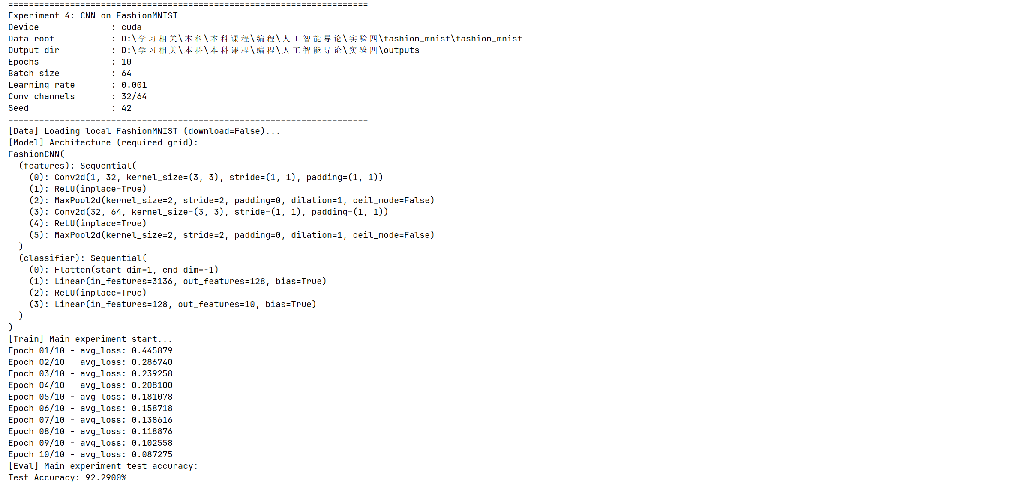
寇天弈 | 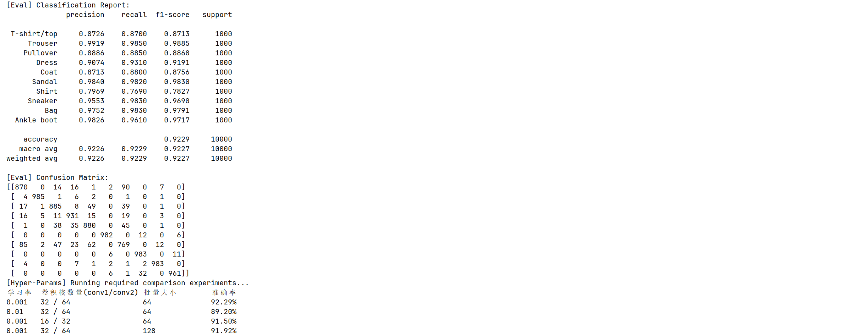  - 损失曲线  Epoch 01: 0.445879  Epoch 02: 0.286740  Epoch 03: 0.239258  Epoch 04: 0.208100  Epoch 05: 0.181078  Epoch 06: 0.158718  Epoch 07: 0.138616  Epoch 08: 0.118876  Epoch 09: 0.102558  Epoch 10: 0.087275  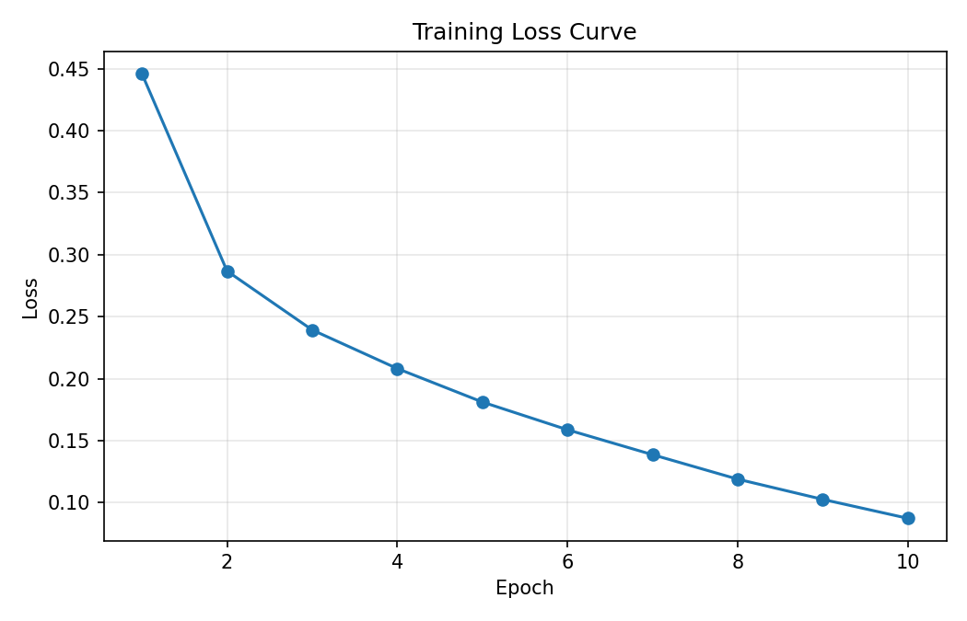  分析：结果表明训练损失持续下降，模型收敛稳定  - 测试准确率  Test Accuracy: 92.29%  - 分类结果展示  随机抽取 8 张测试图像，展示模型的预测结果（正确/错误）。  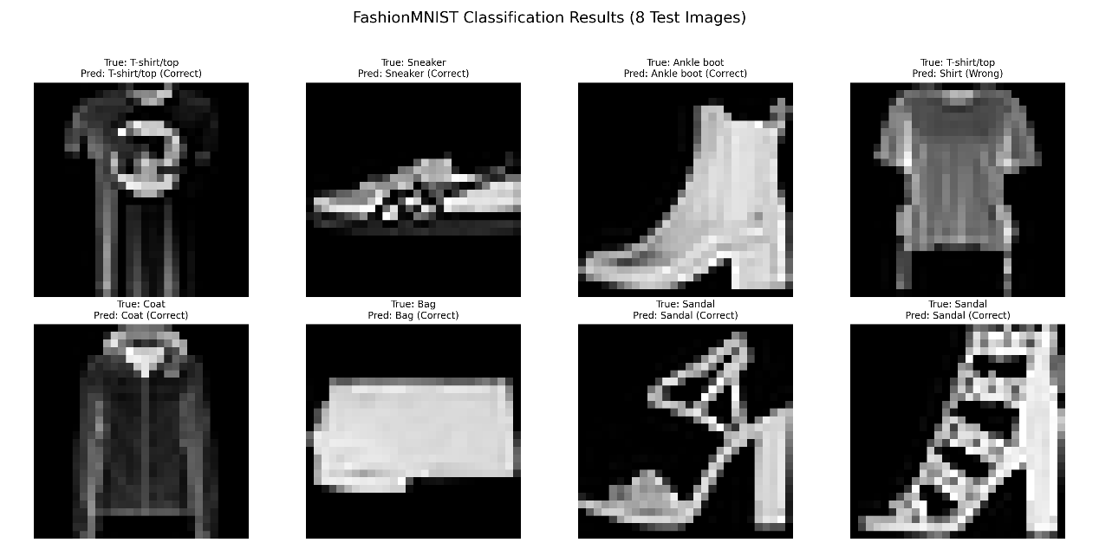  - 超参数影响分析（若进行多组实验）  1.学习率影响最明显：0.01相比0.001准确率明显下降，说明学习率过大会导致优化不稳定。  2.卷积通道数影响模型容量：16/32相比32/64准确率下降，说明特征提取能力减弱。  3.批量大小影响收敛细节：128相比64准确率略低，可能与参数更新频次减少有关。
  学习率 | 卷积核数量 | 批量大小 | 测试准确率
  0.001 | 32/64 | 64 | 92.29%
  0.01 | 32/64 | 64 | 89.20%
  0.001 | 16/32 | 64 | 91.50%
  0.001 | 32/64 | 128 | 92.02%
秦天
秦天 | 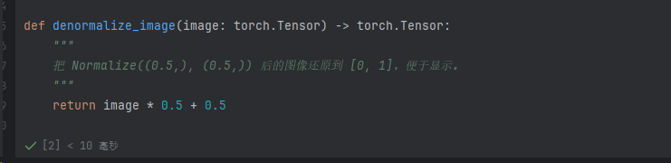
秦天 | 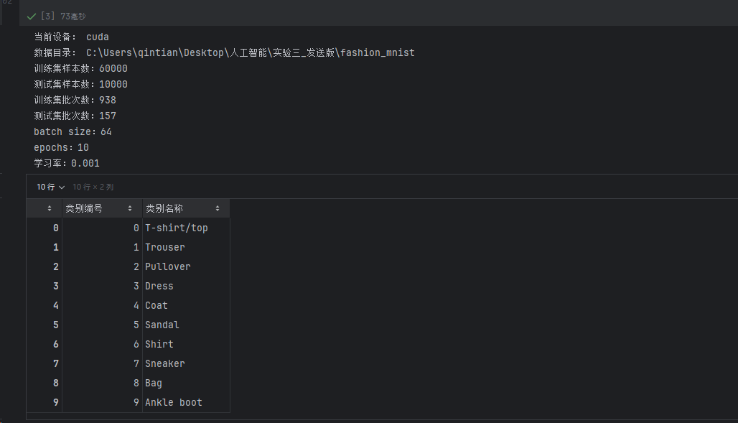
秦天 | 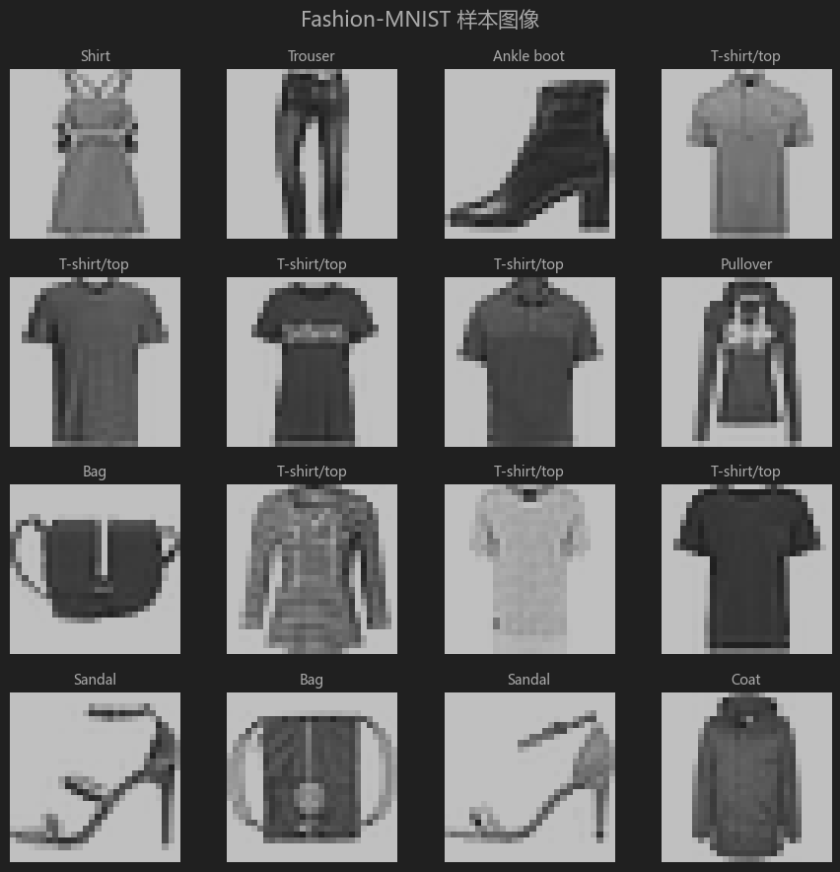  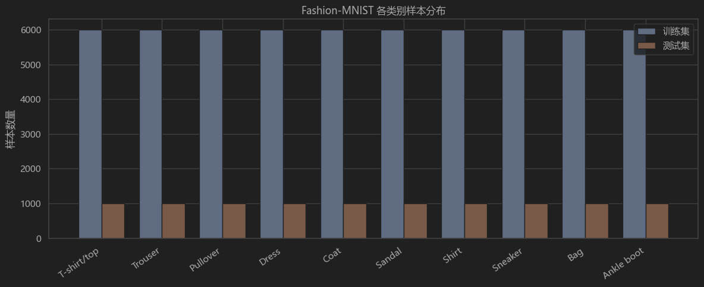  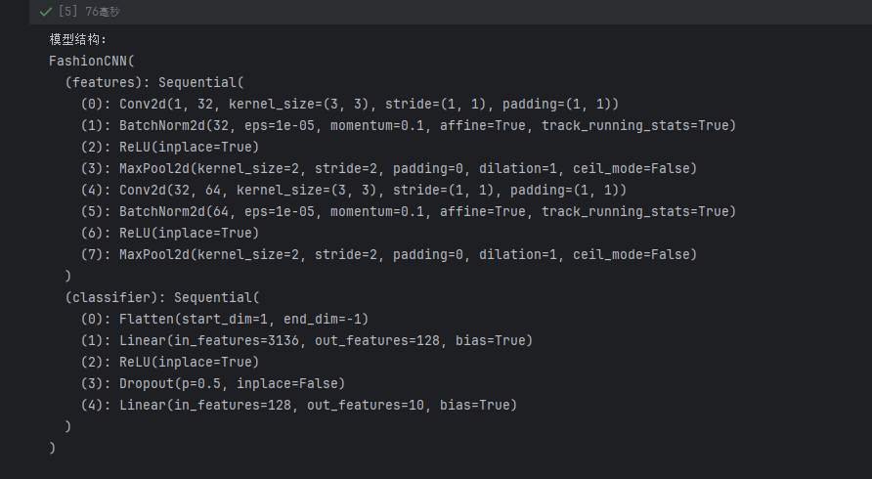  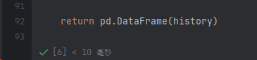  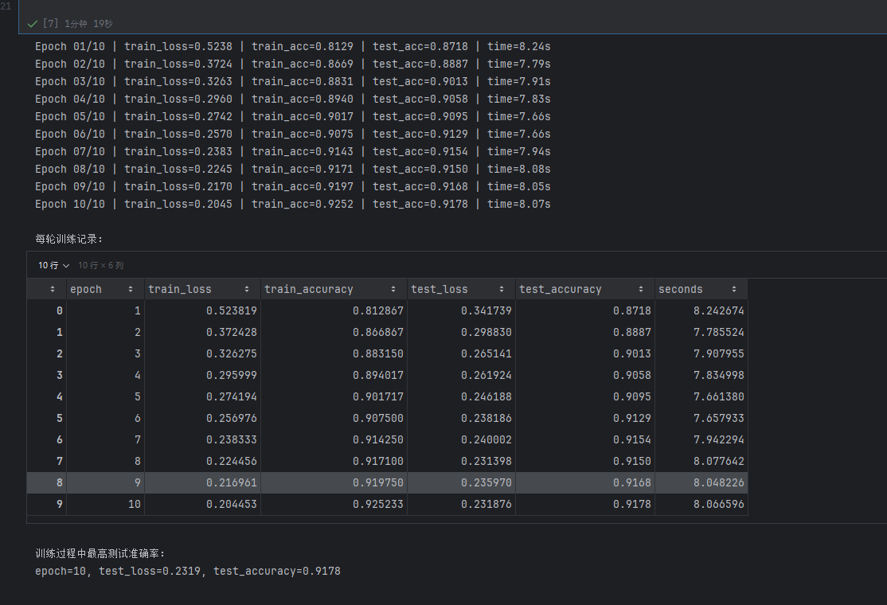  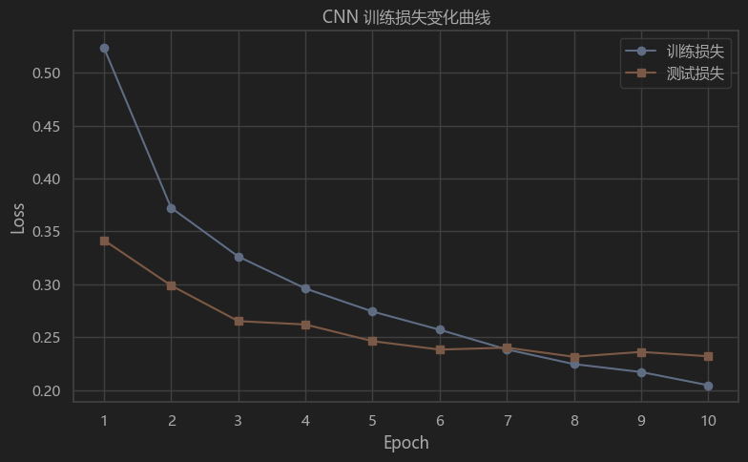  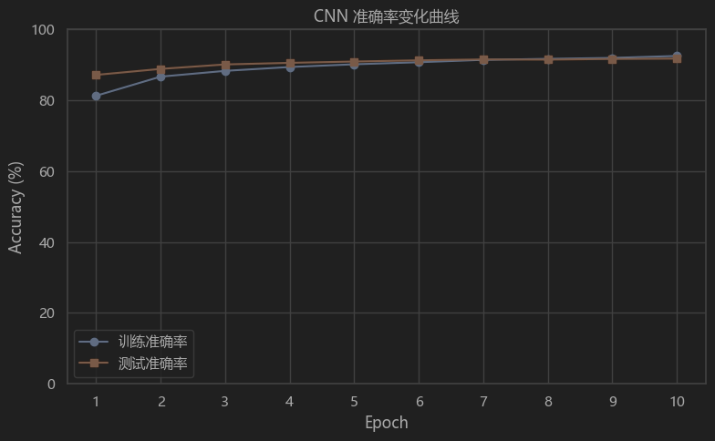  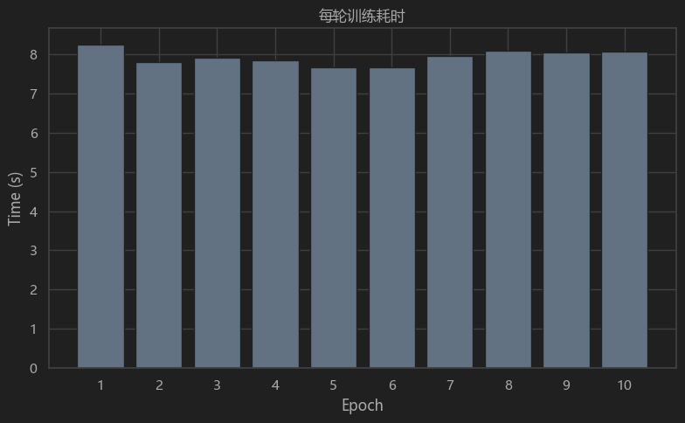  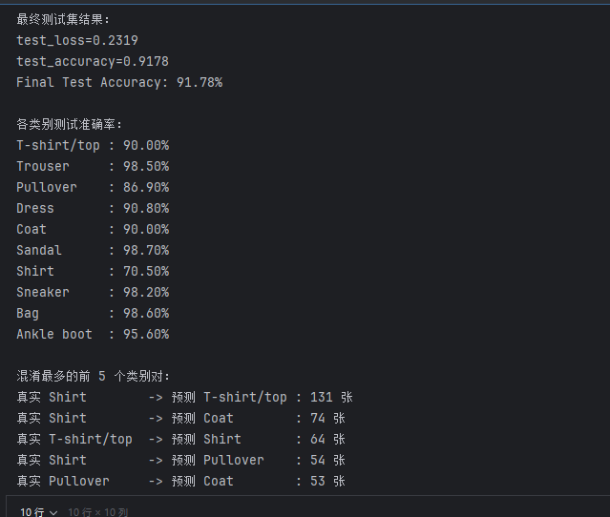  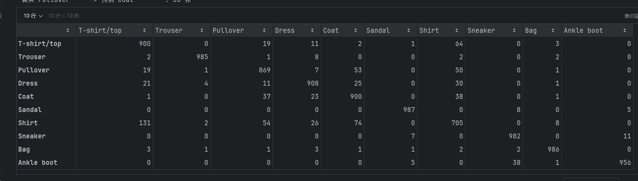  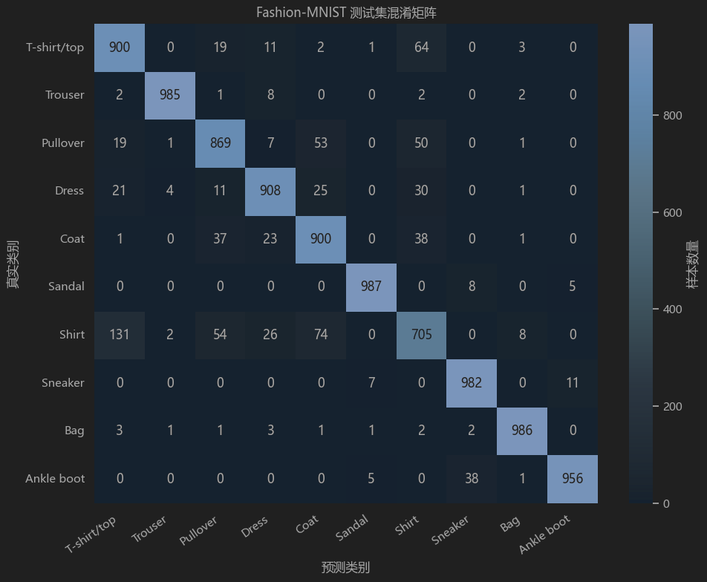  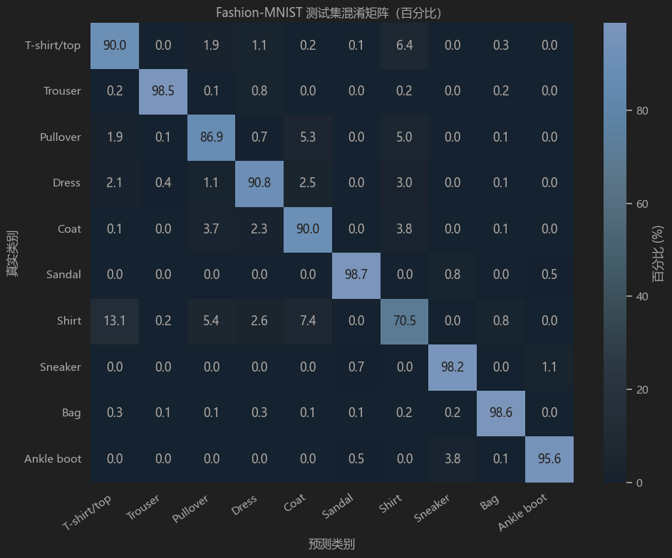  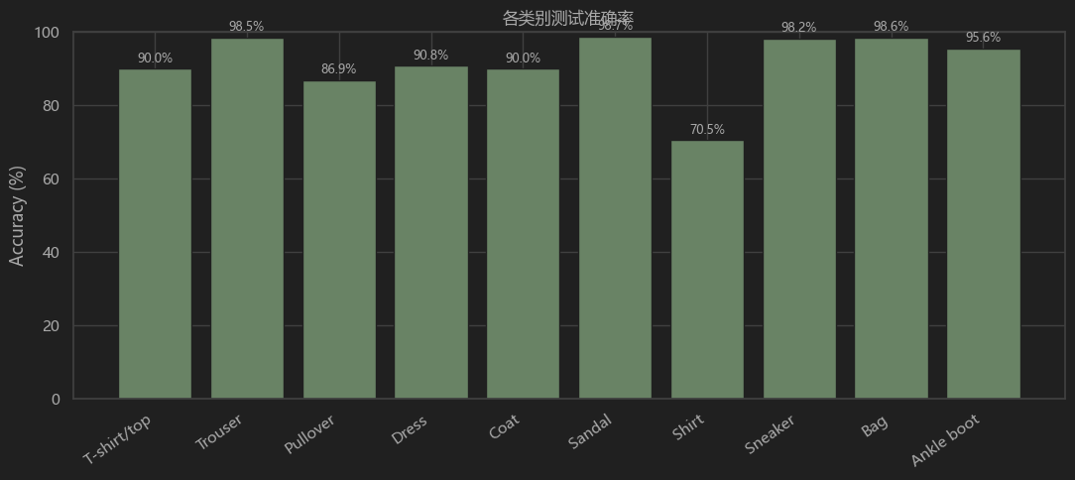  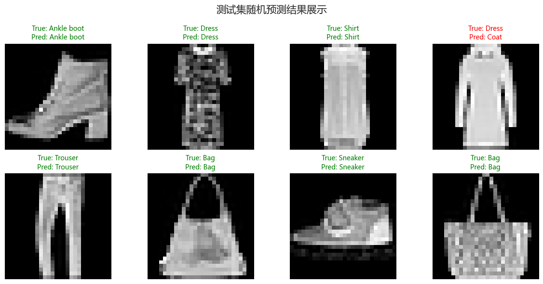  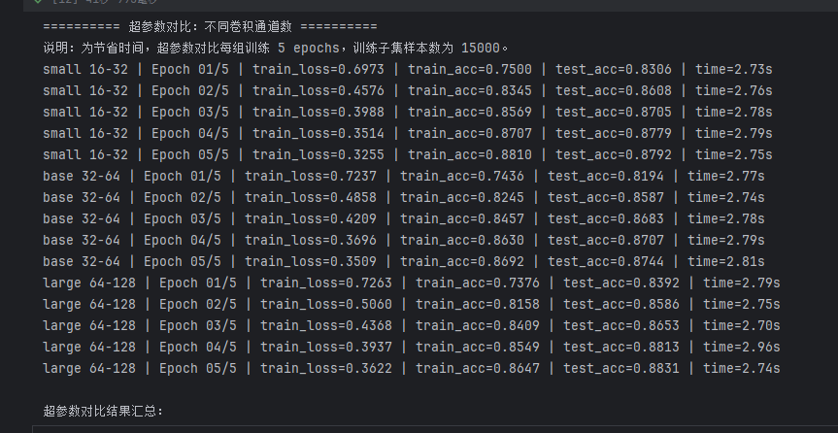  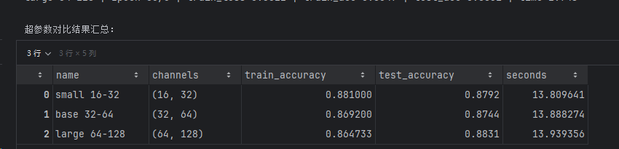  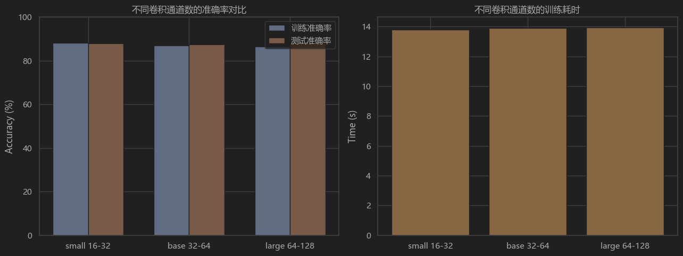
结果分析

本次实验主要完成了基于 Fashion-MNIST 数据集的卷积神经网络分类任务。实验中使用了两层卷积层、两层池化层和两层全连接层来搭建 CNN 模型，损失函数采用交叉熵损失，优化器使用 Adam。训练过程中记录了每轮的训练损失、训练准确率和测试准确率，并绘制了损失曲线、准确率曲线、混淆矩阵以及随机测试样本预测结果图。

从实验过程来看，CNN 比实验三中的 MLP 更适合处理图像分类任务。MLP 在输入时需要把 `28×28` 的图片直接展平成一维向量，这样会弱化图像中原本的空间结构；而 CNN 通过卷积核在图像上滑动，可以利用局部感受野提取边缘、纹理和形状等局部特征。同时，卷积层的权值共享减少了模型参数，池化层又对特征图进行了下采样，使模型在保留主要信息的同时降低了计算量。

在实验结果中，训练损失整体呈下降趋势，说明模型在逐渐学习 Fashion-MNIST 中不同服饰类别的特征。准确率曲线也能反映出模型分类能力的提升。通过混淆矩阵可以看到，模型对 Trouser、Bag、Sandal、Sneaker、Ankle boot 这类特征比较明显的类别识别效果通常较好，而 Shirt、T-shirt/top、Pullover、Coat 这些外形相近的类别更容易发生混淆。这也比较符合实际观察，因为这些衣服在灰度小图中轮廓差异并不算特别明显。

实验过程中也遇到了一些小问题。首先是数据集路径问题，实验四文件夹里一开始没有 Fashion-MNIST 数据，因此代码中增加了路径判断：优先读取实验四目录下的数据集，如果没有，就自动回退到实验三目录中的 `fashion_mnist` 文件夹，避免重复下载。另外，绘图时中文标题可能乱码，因此设置了 `Microsoft YaHei`、`SimHei` 等中文字体。超参数对比部分如果完整训练会比较耗时，所以只使用部分训练样本并减少训练轮数，用来观察不同卷积通道数对结果和耗时的大致影响。

通过本次实验，我们对 CNN 的基本流程有了更完整的理解：卷积层负责提取局部特征，池化层负责压缩特征图，全连接层负责根据提取到的特征完成分类。相比实验三的全连接网络，CNN 更能保留图像的二维结构，也更符合图像数据本身的特点。后续如果继续改进，可以尝试增加训练轮数、调整卷积通道数、加入数据增强或学习率调度等方法，进一步提升模型在测试集上的分类效果。

